PRACTICAL 5 – BUG REPORT SCREENSHOT REPORT
DEFECT IDENTIFICATION AND BUG REPORTING
Sample Application: Automation Exercise – Login Module
Date: ____________________

Aim
To identify defects in a sample application and prepare professional bug reports containing severity, priority, screenshots and clear reproduction steps.

Problem Statement
Review the login module of a sample web application, document possible defects in a structured format, classify their severity and priority, and include steps that another tester can follow to reproduce each issue.

Tools Used
Sr. No. | Tool / Resource | Purpose
1 | Automation Exercise website (sample target) | Example login module for defect-reporting practice
2 | Google Chrome | Browser for viewing the login interface
3 | Bug report / defect log | Record defect details, severity, priority and status
4 | Screenshot evidence | Show the observed interface state for each example

Defect Reporting Basics
Field | Meaning
Bug ID | Unique reference number for tracking the defect
Title | Short description of the issue
Severity | How much the defect affects the system or user (e.g., Major, Minor)
Priority | How urgently the defect should be fixed (e.g., High, Medium)
Steps to Reproduce | Numbered steps that allow another person to see the issue
Expected Result | What should happen according to the requirement
Actual Result | What happened during the observed test
Status | Current state of the report, such as Open, Assigned, Fixed or Closed

The examples below are prepared for learning how to write bug reports. Confirm each issue in the actual application before submitting it as a real defect.

1. BUG-01 – Invalid password does not show a clear error message
Field | Details
Bug ID | BUG-01
Title | Invalid password does not show a clear error message
Module | Login
Defect Type | Functional
Severity | Major
Priority | High
Environment | Google Chrome / Windows (sample environment)
Precondition | Login page is open
Test Data | Registered email / incorrect password
Steps to Reproduce | 1. Open the Login page.  2. Enter a registered email address.  3. Enter an incorrect password.  4. Click Login.
Expected Result | Login should be rejected and a clear error message should be displayed.
Actual Result | The page does not show a clear error message for the invalid password.
Status | Open
Assigned To | To be assigned

Screenshot Evidence:
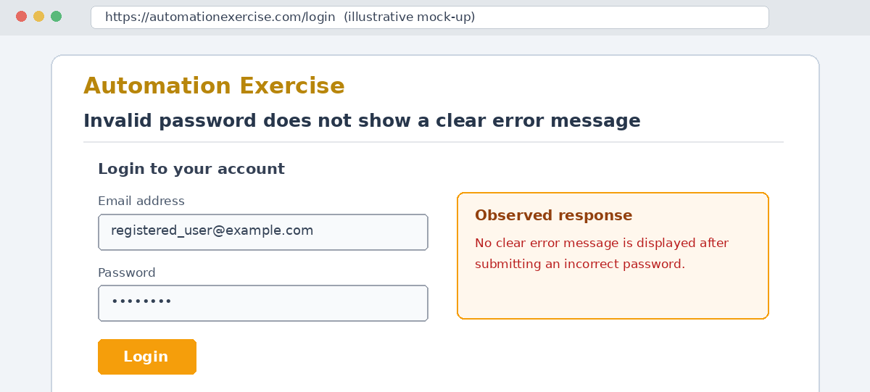

2. BUG-02 – Login form accepts submission with blank email
Field | Details
Bug ID | BUG-02
Title | Login form accepts submission with blank email
Module | Login
Defect Type | Validation
Severity | Major
Priority | High
Environment | Google Chrome / Windows (sample environment)
Precondition | Login page is open
Test Data | Blank email / any password
Steps to Reproduce | 1. Open the Login page.  2. Leave the email field blank.  3. Enter a password.  4. Click Login.
Expected Result | The form should prevent submission and display email validation.
Actual Result | The form attempts to submit without showing a clear email-required message.
Status | Open
Assigned To | To be assigned

Screenshot Evidence:
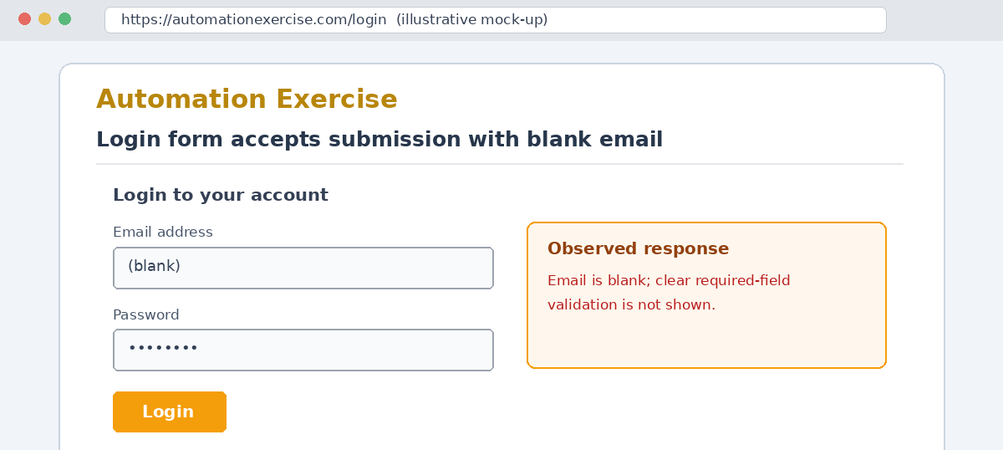

3. BUG-03 – Login error message is not user-friendly
Field | Details
Bug ID | BUG-03
Title | Login error message is not user-friendly
Module | Login
Defect Type | Usability
Severity | Minor
Priority | Medium
Environment | Google Chrome / Windows (sample environment)
Precondition | Login page is open
Test Data | invalid_user@example.com / wrong123
Steps to Reproduce | 1. Open the Login page.  2. Enter an invalid email and password.  3. Click Login.  4. Read the displayed response.
Expected Result | A clear, readable message should explain that the credentials are incorrect without exposing sensitive details.
Actual Result | The response is unclear or difficult to notice.
Status | Open
Assigned To | To be assigned

Screenshot Evidence:
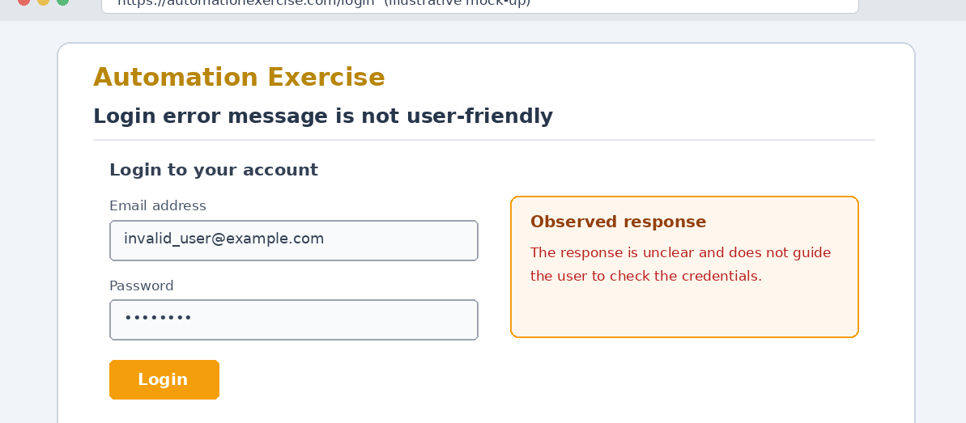

Bug Summary
Bug ID | Short Description | Severity | Priority | Status
BUG-01 | Invalid password does not show a clear error message | Major | High | Open
BUG-02 | Login form accepts submission with blank email | Major | High | Open
BUG-03 | Login error message is not user-friendly | Minor | Medium | Open

Observation
- A good bug report should be clear, short and easy to reproduce.
- Severity describes the impact of the issue, while priority indicates how soon it should be fixed.
- Screenshots and test data help developers understand the reported behaviour.
- Defects should be retested after a fix, and the report should be closed only when the result is verified.

Conclusion
In this practical, sample defects related to the login module were documented using a structured bug-report format. Each report includes a title, module, severity, priority, test data, reproduction steps, expected and actual results, status and visual evidence. The reports demonstrate how testers communicate issues clearly so the development team can investigate and resolve them.

Student Name: __________________________
Enrollment No.: _________________________
Class / Division: BCA Semester 3
Signature with Date: _____________________

